S.E.S COLLEGE, SREEKANDAPURAM

DEPARTMENT OF ENGLISH

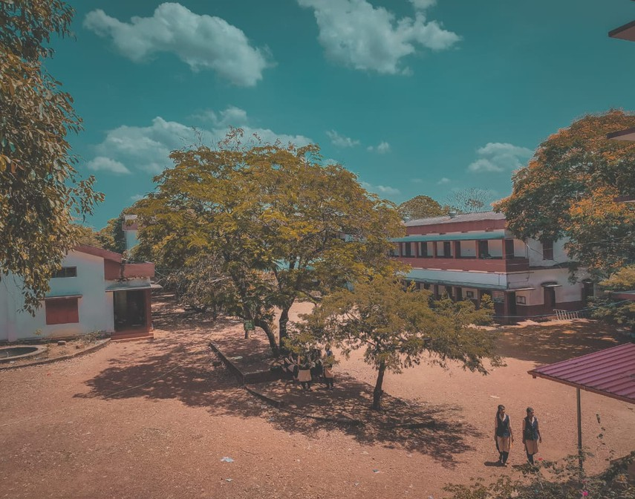

ACTIVITY REPORT-2024-25

DEPARTMENT ORIENTAION CLASS FOR FIRST YEARS

An Orientation Class was organised for First Year B.A. English students on October 16, 2024 titled “Memory Revisited : The Art of Storytelling” from 9.30am at the Seminar Hall. The Resource Person was Sr. Dr. Sonia Philomena V.A. She engaged the session by focusing on the precepts of Memory studies and relating literary studies as part of memory narrations.
OBJECTIVE : To orient the students to the field of language and literature studies

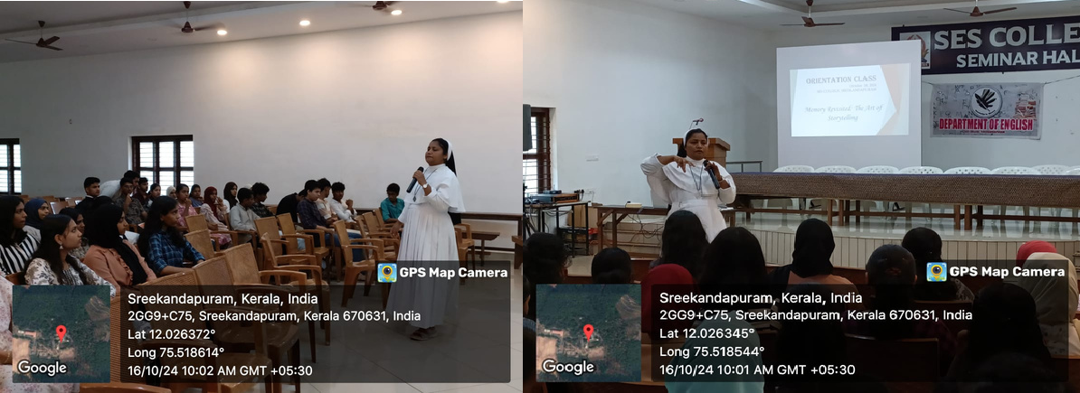
OUTCOME : The students achieved basic notions of literature and language studies
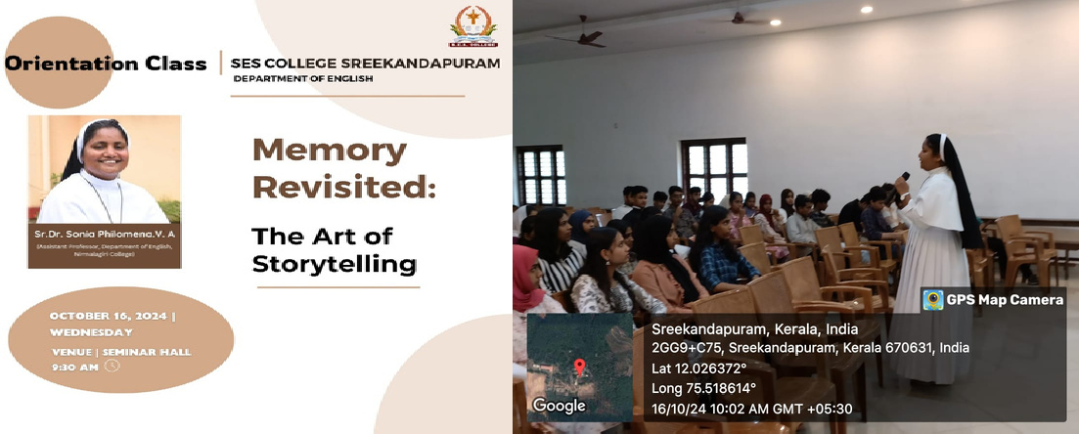

LITERATI- BOOK CLUB SESSION-1

The Department of English at SES College organized the inaugural meeting of the Literati Book Club on September 5, 2024, at 1:30 p.m. in the first-year English classroom. The club was formed to encourage a deep-rooted passion for reading among students and to create a space for literary discussions. A total of 43 students, comprising both new and seasoned readers from the department, attended the event. The session began with Ms. Rosemaria Dominic's opening remarks, which highlighted the club's vision and goals. Following this, Ms. Fathimathul Fidha K P delivered a captivating presentation on her favorite author, Jane Austen, specifically focusing on Austen’s celebrated novel Sense and Sensibility. Ms. Fidha’s engaging storytelling and insightful analysis of the novel kept the students hooked, with many expressing an eagerness to read the book and discuss its themes further.
Objectives
To introduce the Literati Book Club to the students and outline its objectives of promoting reading and literary discussions.
To foster an appreciation for classic literature, starting with Jane Austen's Sense and Sensibility.
Outcomes
The students displayed a keen interest in the book and the presentation, with several expressing enthusiasm about becoming active members of the club.

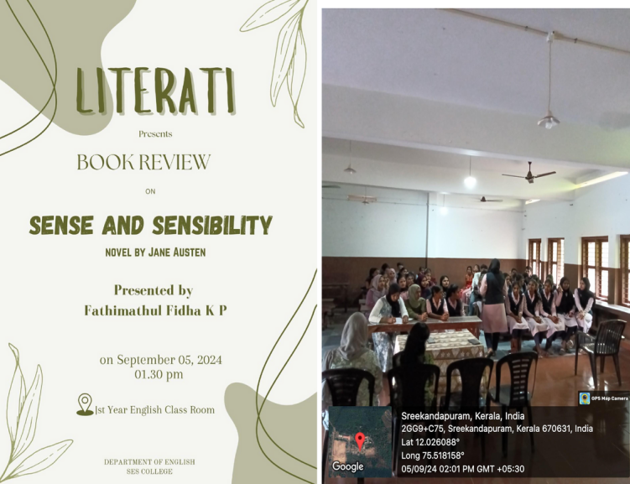

LITERATI- OCTOBER (SESSION II)

The Department of English at SES College, Sreekandapuram, held its second meeting of the Literati Book Club on October 18, 2024, at 1:30 p.m. in the college Seminar Hall, with 25 members in attendance. Ms. Rosemaria Dominic supervised the event, where Ms. Nasweeha Abdusalam delivered a captivating presentation on Geoffrey Chaucer's The Canterbury Tales.
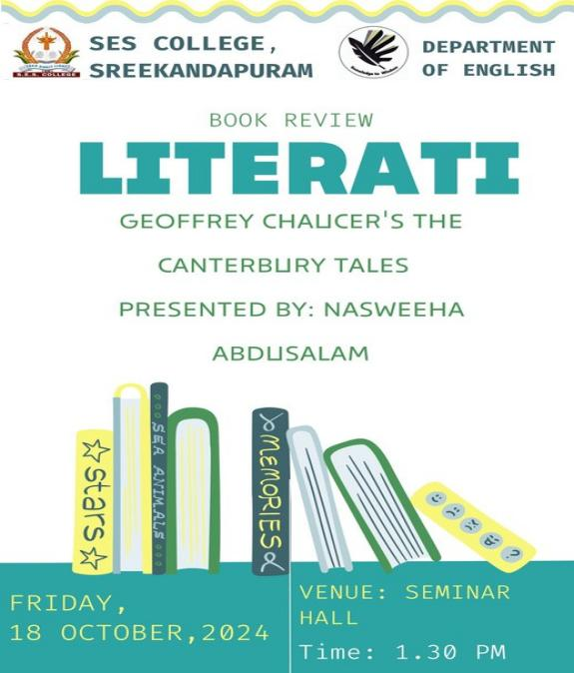
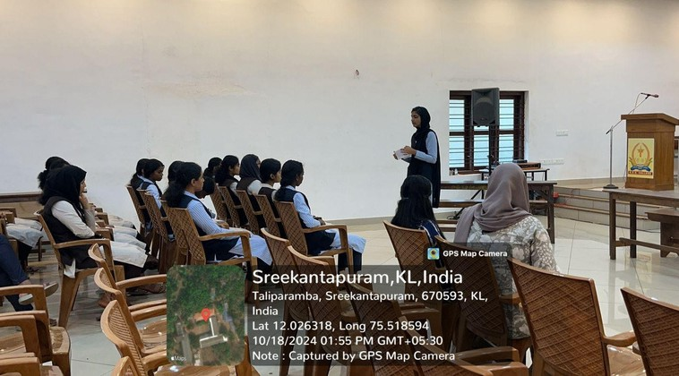
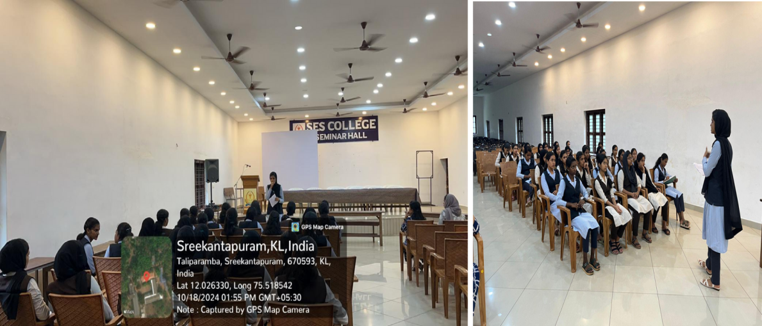

LITERATI- NOVEMBER (SESSION III)

The Department of English at SES College, Sreekandapuram, held its third meeting of the Literati Book Club on November 22,2024, at 1:30 p.m. in the college Seminar Hall. Ms. Rosemaria Dominic supervised the event, where Ms. Anagha K P delivered a session on Shakespeare’s Hamlet

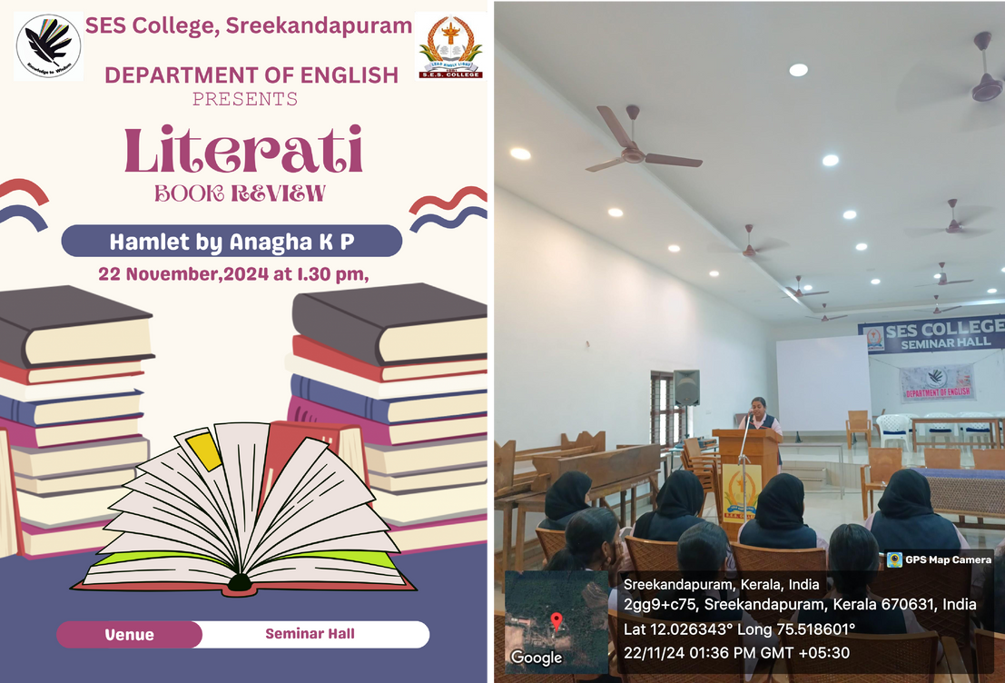

LITERATI- DECEMBER (SESSIONIV)

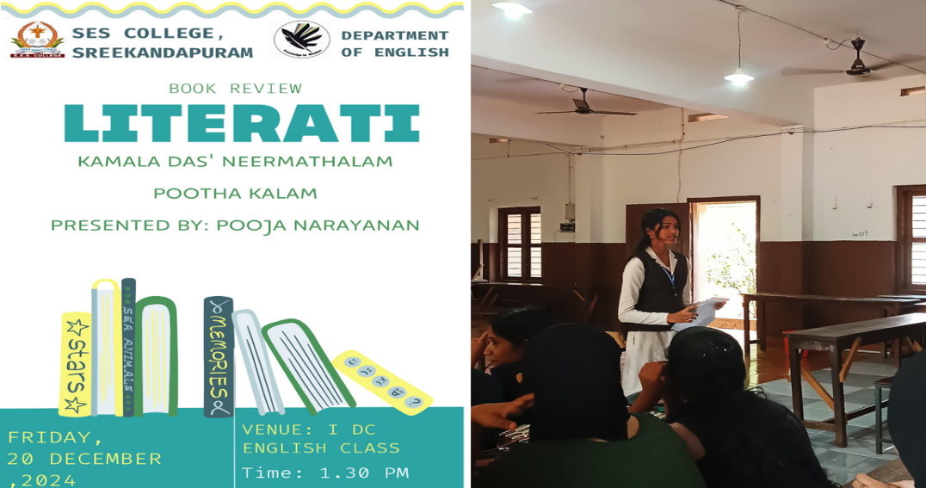
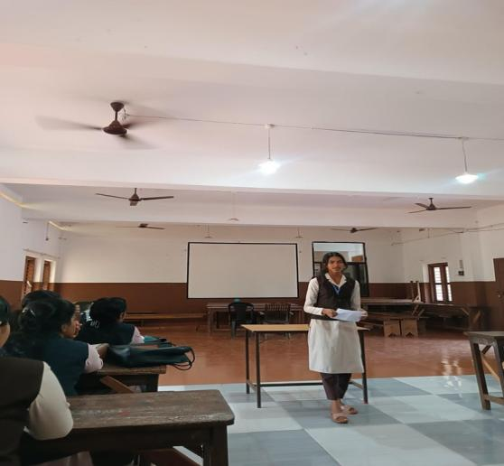
The fourth meeting of the Literati Book Club took place in December 2024, where Ms. Pooja Narayanan shared her insights on the well-known Malayalam novel Neermathalam Pootha Kalam by Kamala Das.

LITERATI- JANUARY- (SESSION V)

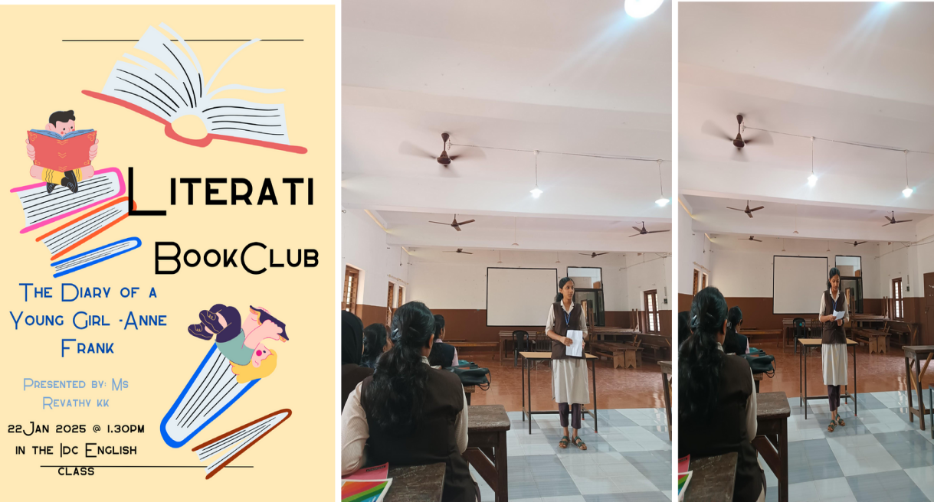
On January 22, 2025, at 1:30 p.m., the Department of English at SES College, Sreekandapuram, hosted the fifth meeting of the Literati Book Club in the IDC English classroom. During the meeting, Ms. Revathy K K delivered an insightful presentation on The Diary of a Young Girl by Anne Frank.

LITERATI - FEBRUARY(SESSIONVI)

On February 21, 2025, at 1:30 p.m., the Department of English at SES College, Sreekandapuram, hosted the sixth meeting of the Literati Book Club in the IDC English classroom. The session featured a presentation by Ms. Shibina Mariya, a final-year student.

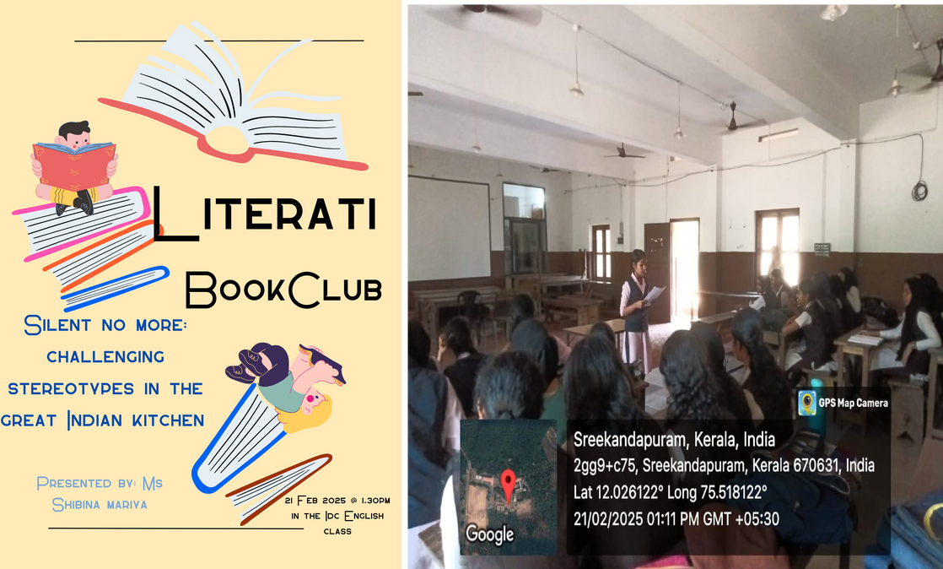

LITERATI- -MARCH (SESSION VII)

On March 3, 2025, at 1:30 p.m., the Department of English at SES College Sreekandapuram, held the final meeting of the Literati Book Club for the academic year in the IDC English classroom.

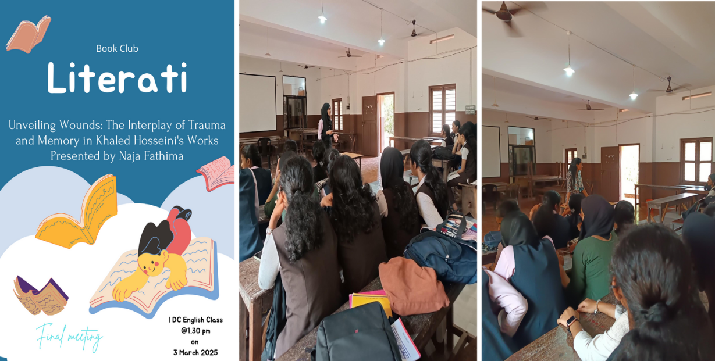

SPELL-TACULAR-SPELL BEE COMPETITION

The Department of English, SES College, hosted an inter-department spell bee competition titled "Spell- tacular" on October 18, 2024, at 2 pm in the seminar hall. . About fifty students from the college attended the programme. Two students from each department participated in the competition. The second-year students of the English Department coordinated the programme and Ms. Rasha K T, Assistant Professor of English, supervised the event. Amarnath C C and Neeraja from the Physics Department were the winners. Mr. Samson Rajan, Assistant Professor of English, distributed the prize.

OBJECTIVE

The core objective is to help students learn and remember the correct spellings of various words. Spelling bee competitions expose students to a wide range of words, increasing their vocabulary and understanding of word meanings.

OUTCOME
Participants become more proficient in spelling, which can be beneficial in various academic and professional settings.Students acquire a larger vocabulary, enabling them to communicate more effectively and express themselves with greater precision.

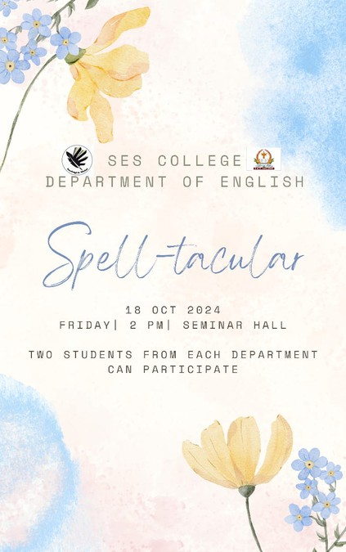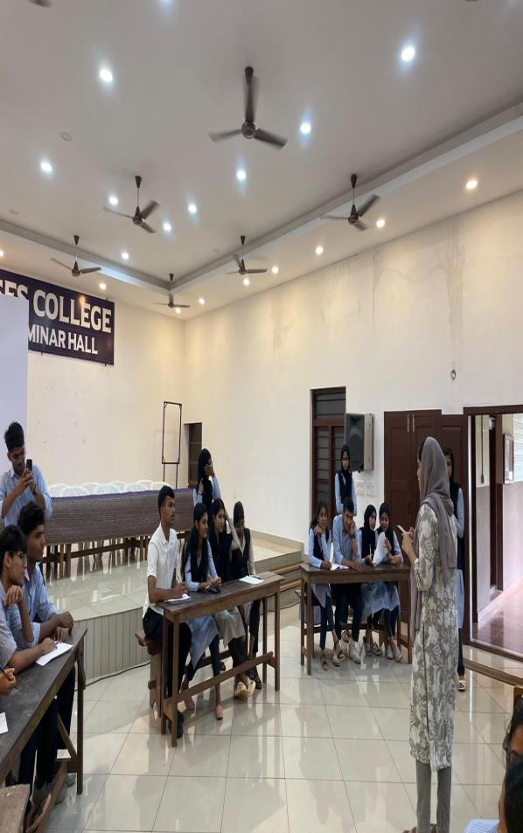
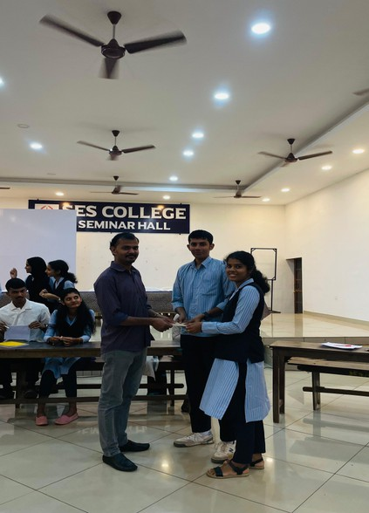

E.A.S.E.S TALK- ALUMNI INTERACTION

The Department of English at SES College, Sreekandapuram, conducted an inspiring session under the banner of E.A.S.E.S Talks on 12th November 2024. The session, titled "Alumni Interaction," featured Mr. Josbin Joseph, an esteemed alumnus of the department, as the resource person.
Mrs. Shyna Janardhanan, HOD of English Department welcomed the gathering. His talk inspired students to set goals, develop skills, and stay committed to their ambitions.

Objective:
To connect students with successful alumni, inspiring them through shared experiences, career insights, and motivational discussions that promote academic and professional development.

Outcome:
Participants gained a deeper understanding of future opportunities and real-life applications of their academic learning. The session also helped students build aspirations, set goals.

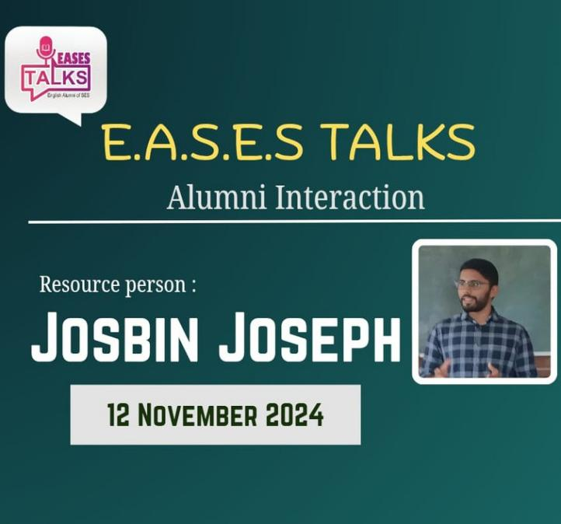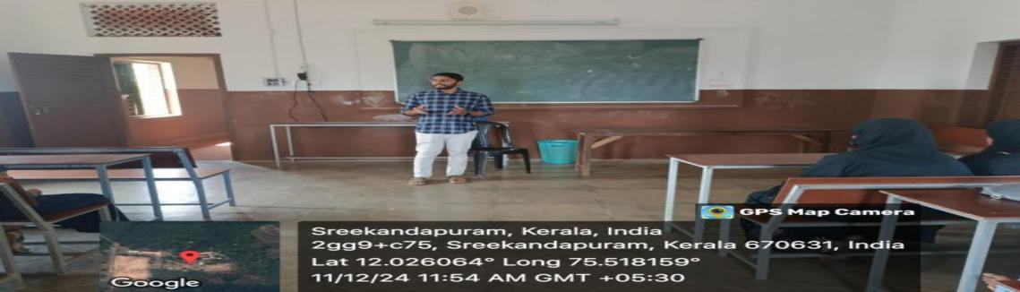

GESTURE QUEST

The Department of English organized an engaging and insightful program titled "Gesture Quest" to emphasize the importance of non-verbal communication. The program was conducted under the supervision of Ms. Rosemaria Dominic, on 22 November, 2024 at 2pm in the college Seminar Hall ,which was attended by 54 students from various departments.The event kicked off with a session on “Understanding Sign Language”,
The activities included Dumb Charades and Passing the Action Game, a fun and engaging exercise where participants acted out words or phrases without speaking, relying solely on gestures.

Objectives of the Event
To raise awareness about the significance of non-verbal communication in
everyday life.
To introduce students to sign language and its practical applications for interacting with mute and deaf individuals.

Outcomes of the Event
Students gained valuable knowledge about sign language and its role in fostering inclusive communication.
Participates enhanced their non-verbal communication skills through engaging and interactive group activities.
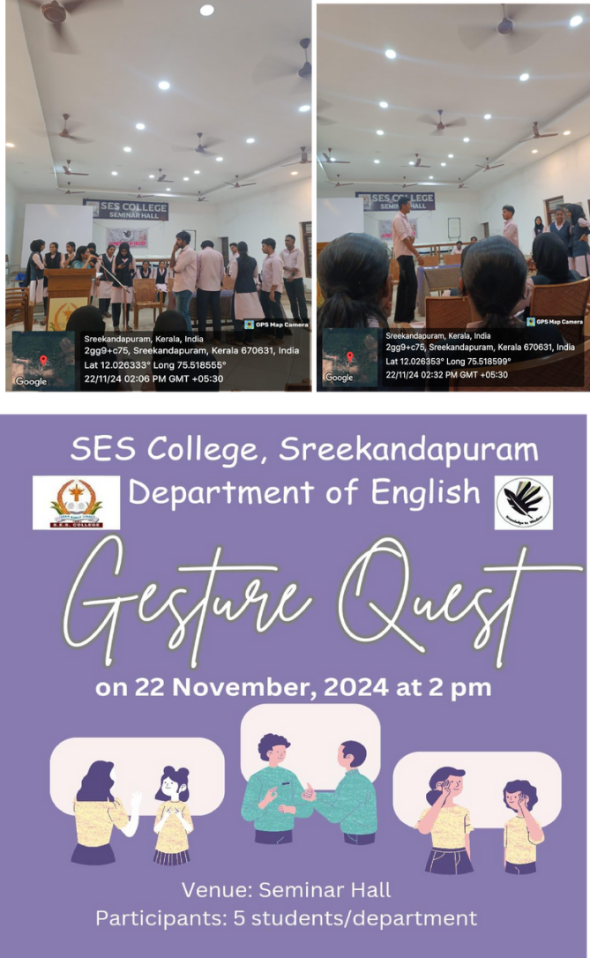
.

WORKSHOP ON RESEARCH METHODOLOGY: THE BASICS

On January 23, 2025, the Department of English, SES College, organized an interactive class titled “Research Methodology: The Basics” for all second- and third-year English students.The resource person for the program was Ms. Athira Hari, a Junior Research Fellow(JRF) and research scholar. She introduced the foundational concepts of research, including research design, data collection methods, literature review, and academic writing. The session emphasized the importance of research in higher education and was tailored to suit the academic needs of undergraduate students.

Objective:
To introduce undergraduate English students to the fundamentals of research methodology and help them understand the basics required for academic research and project work.
Outcome:
Participants gained a foundational understanding of research principles and
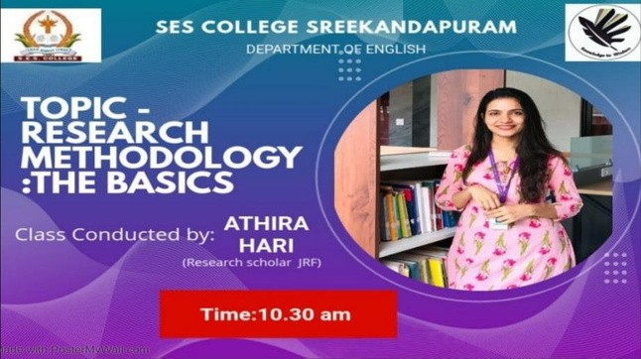
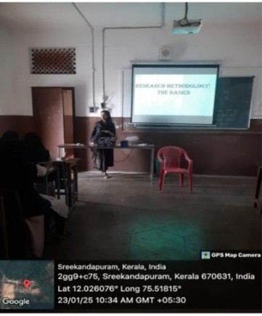
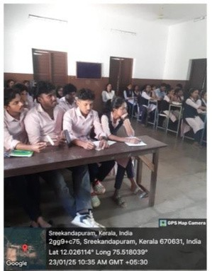
methods, helping them prepare for future academic projects and studies. The session successfully raised awareness about the importance of research in the field of English literature and language.

SOCIAL EXTENSION ACTIVITY - AT AARALAM WILDLIFE SANCTUARY

The Department English of SES College Sreekandapuram organized a social extension activity 03/02/2025 to Aaralam Wildlife Sanctuary.Mr. Gopalakrishan, Assistant Professor of English Department accompanied with students. A team of eight students– Nasweeha, Jinan, Afsal, Aswathi, Anagha, Riya, Nandana, Thejas representing English took part in the extension activity. A forest guard assisted the group throughout the visit to the wildlife sanctuary, providing valuable information about the animals and plants following sanctuary's guidelines. Another oﬃcial from the sanctuary delivered an informative session about Sanctuaries importance and later guided the group through the museum, explaining the exhibits in detail.

Objective:

To provide students with real-world exposure to environmental conservation and wildlife protection, and to enhance their understanding of biodiversity and ecological responsibility.

Outcome:

Students gained knowledge about the importance of wildlife conservation and the role of sanctuaries in protecting biodiversity. The visit also fostered environmental awareness and a sense of responsibility among the participants.
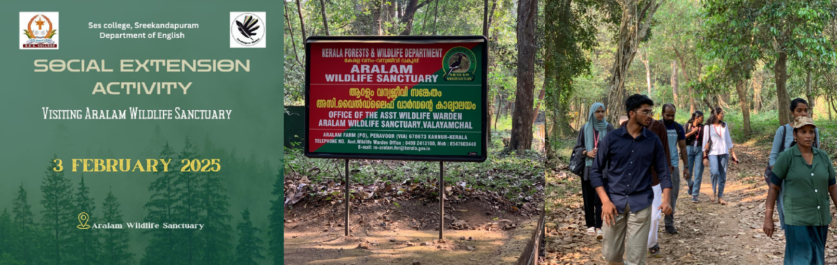

SESSION ON COMMUNICATIVE ENGLISH

On February 11, 2025, the Department of English, SES College, organized a session on Communicative English. The session was led by Mr. Jobish M Joseph (M.A., M.Phil., M.Ed.), who served as the resource person for the program.The session included interactive elements and practical tips, making it engaging and highly beneficial for all participants.

Objective:
To enhance students’ proficiency in English communication by introducing practical strategies for effective speaking and improving confidence in real-life interactions.
Outcome:
Students developed a better understanding of communicative English, gained useful tips for speaking more fluently and accurately, and showed increased confidence in classroom interactions and beyond.

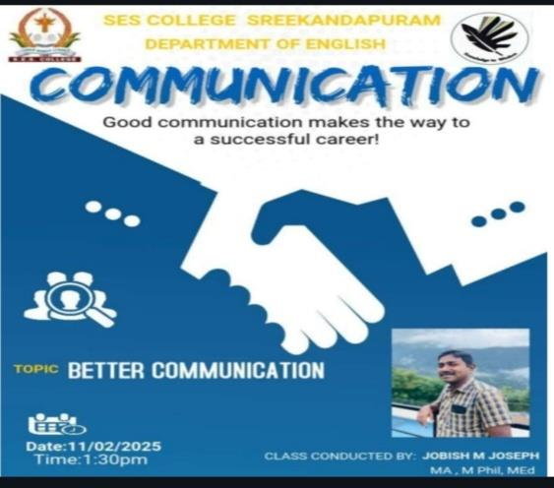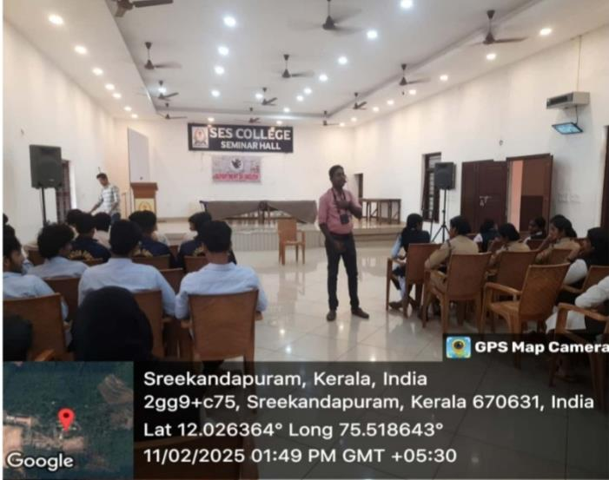

SOFT SKILLS TRAINING PROGRAMME

Department of English organised a Soft skill training class titled “Beyond the Books: Soft Skills for Language and Literature Students” for B.A. English students on Feb 13, 2025 from 10.30am to 12.30pm in the Seminar Hall. The Resource Person was Mr. Sailal N.V., Soft Skill Trainer and Teacher, HSST English, SABTM HSS, Thayineri, Payyannur. The Resource Person elaborated on the relevance of Soft Skills for literature students through group activities and games.
OBJECTIVE:
To equip the students with soft skills

OUTCOME:
The students got motivated to acquire soft skills for better communication

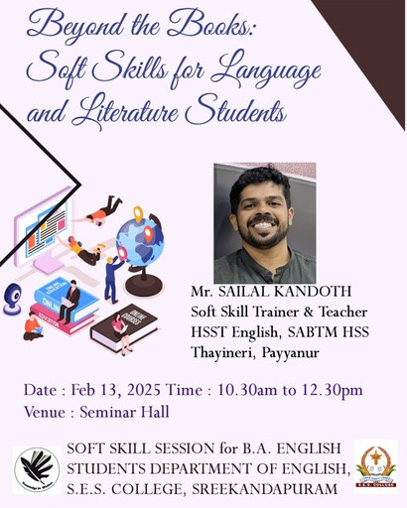
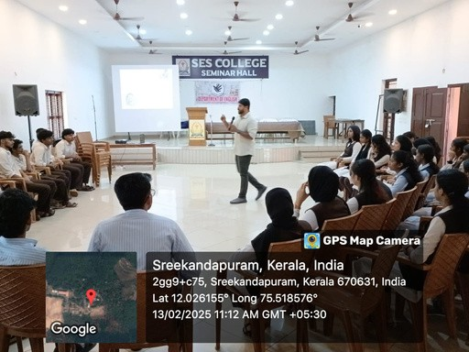
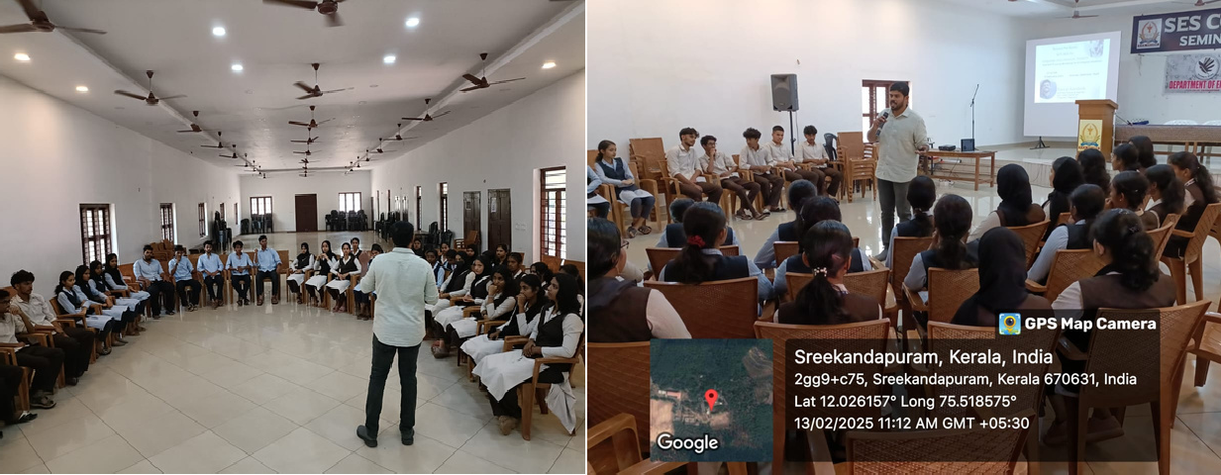
BRAINIAC- QUIZ &DEBATE COMPETITION

The Department English of SES College Sreekandapuram organized quiz and debate competition ‘BRAINIAC’ on 20/2/2025 at the II DC English classroom. Mrs. Shyna Janardhanan, HOD English Department welcomed the gathering. Topic of the debate was " Is social media harmful than beneficial in spreading news". A team of two students representing English, BBA, B.Com, Economics and Mathematics (5Departments) took part in the debate competition. Adharsh and Analraj (II B.Sc. Mathematics) secured the first position in the debate competition; Safeeda K and Jafna PP (I BA Economics) secured the second position. Mr. Sanish MS and Ms. Rosemaria Dominic acted as the judging panel

Objective:

To enhance students' critical thinking, public speaking, and general knowledge through healthy competition in the form of debate and quiz events.

Outcome:

Students developed confidence in expressing opinions and improved their awareness in various fields. The active involvement from multiple departments promoted teamwork, communication skills, and a spirit of healthy competition.
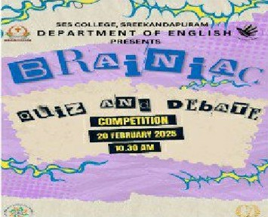

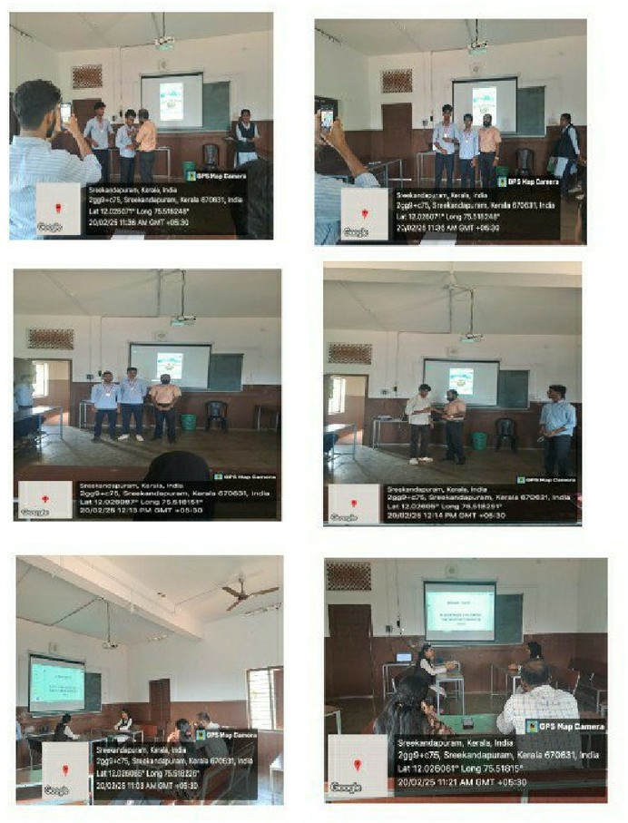

ACADEMIC EXTENSION -CONNECTING TO COMMUNITY

On February 21, 2025, the Department of English at SES College Sreekandapuram organized an event titled “Connecting to Community” at Government Higher Secondary School Sreekandapuram. The event aimed to foster a sense of community and social responsibility among students.
Objective:
The objective of the event was to introduce students to the importance of community engagement and social responsibility.
Outcome:
The event successfully raised awareness about the importance of community engagement and social responsibility among students. Participants gained a deeper understanding of the role they can play in building a stronger, more compassionate community

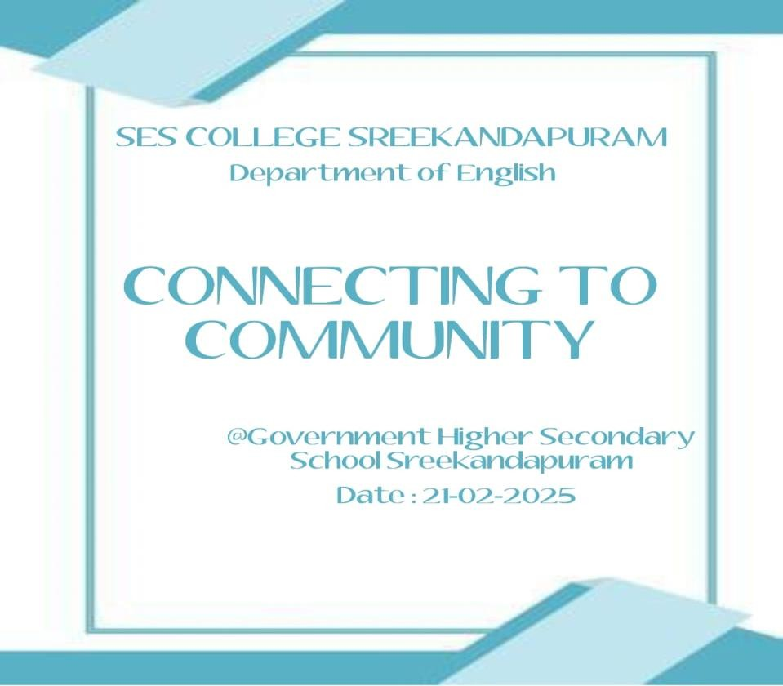

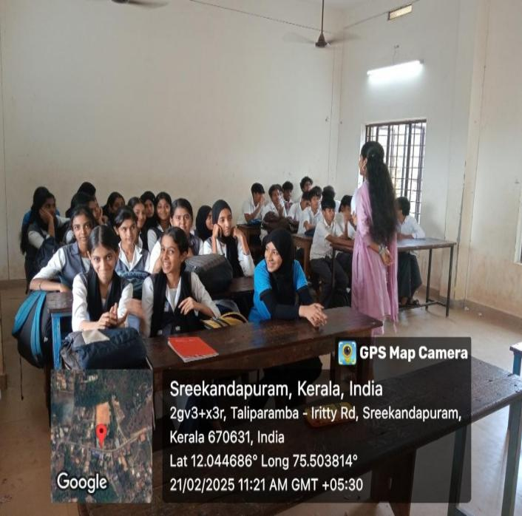
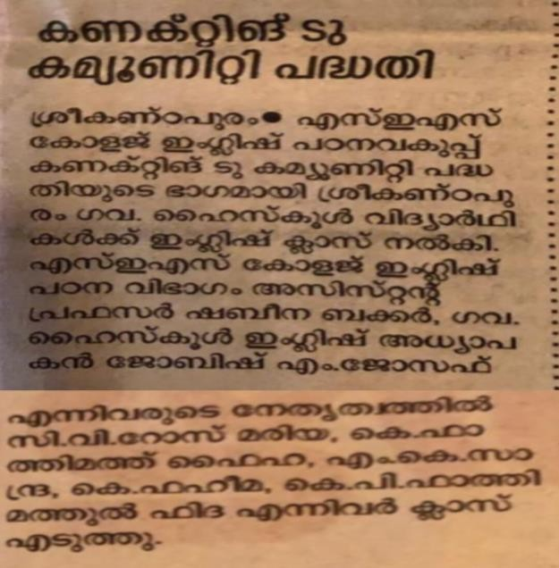
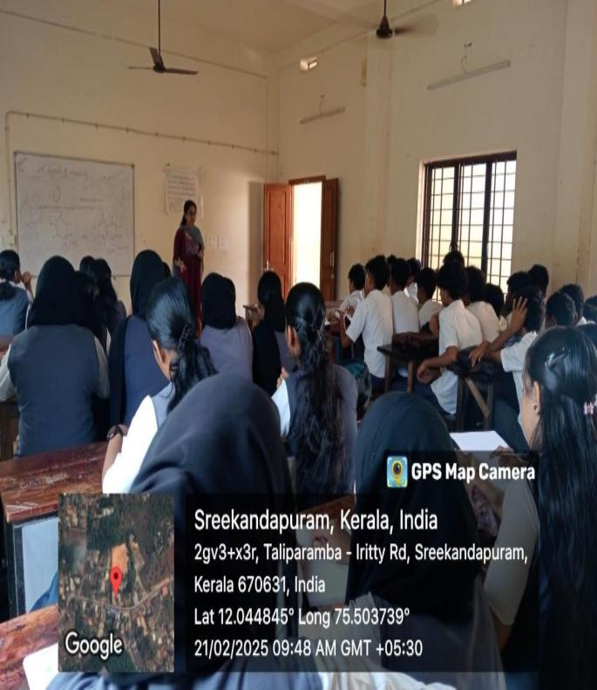

BEYOND THE BOOKS: WHAT’S NEXT FOR ENGLISH MAJORS?

On March 3, 2025, the Department of English, SES College, organized a session titled “Beyond the Books: What’s Next for English Majors?” for all third-year English students.The session was led by Ms. Bindya Sasidharan, Senior Research Fellow, Department of English, Providence Women’s College. She shared valuable insights on various career paths available to English graduates, such as research, publishing, teaching, content writing, civil services, and higher studies.

Objective:
To expose final-year English students to a wide range of academic and professional opportunities available to them beyond graduation, helping them make informed decisions about their future.

Outcome:
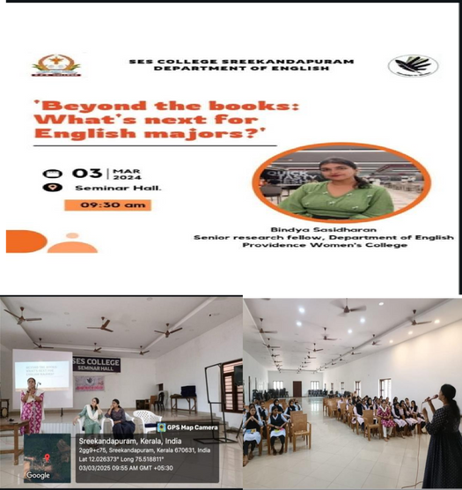
Participants gained a clearer understanding of career options and postgraduate opportunities in the field of English. The session successfully motivated students to plan their next steps and equipped them with knowledge about relevant skills and pathways for further growth.

PEER TEACHING

The final year students of the Department of English have handled session on peer teaching for the second and first year students

OBJECTIVE:

- Encourages students to take ownership of their learning by explaining concepts, answering questions, and providing feedback
- To increase self-esteem and confidence in students as they share knowledge and learn from each other.

OUTCOME

- Studies show peer teaching can lead to better performance on assessments and exams.

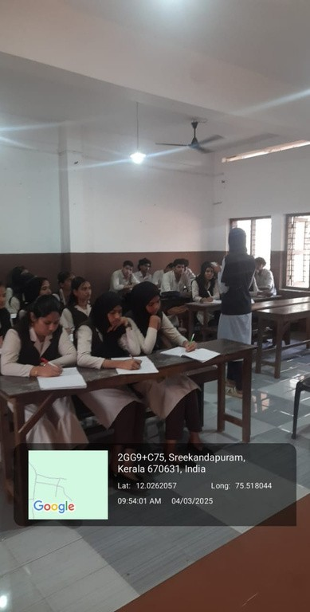
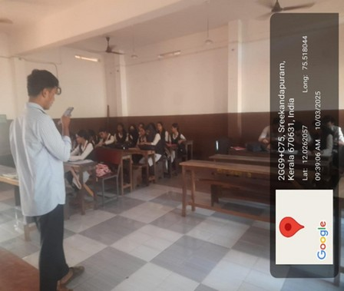
- Students learn to articulate their understanding clearly and effectively when

explaining concepts to their peers.

.

